**Assignment #3**

**Name: Jaspreet Kaur Sekhon**

**Student ID:**

**PROG8170**

**Software Quality Assurance Techniquies**

**__________________________________________________________**

**Decision Tables**

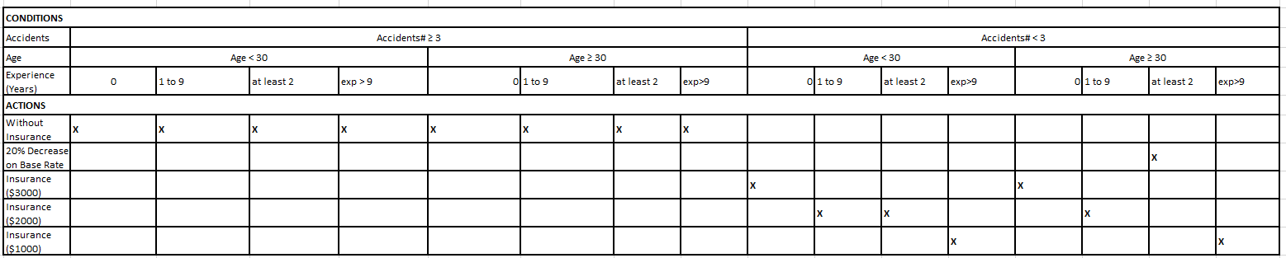

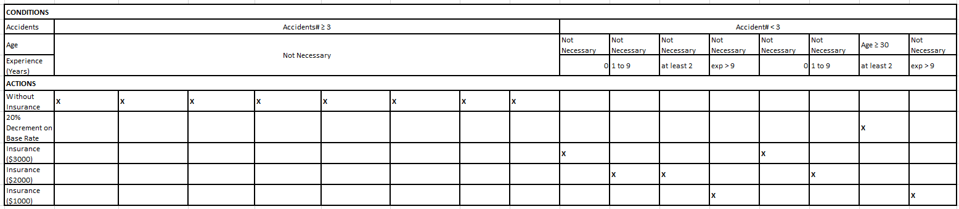

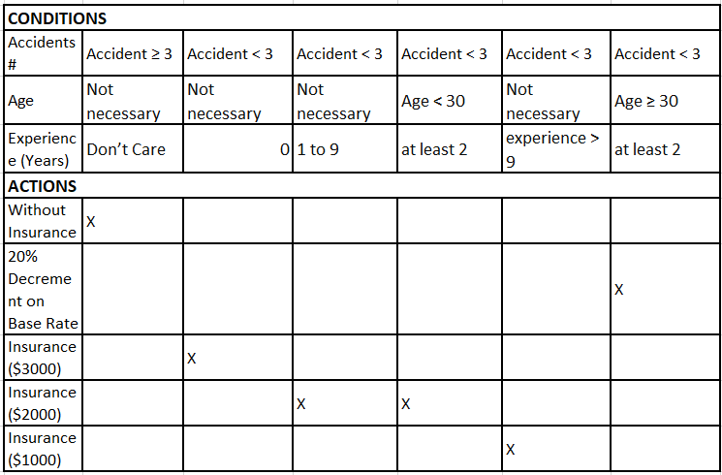

**Test Cases**

|  |  |  |
| --- | --- | --- |
| **Test ID** | **Test Steps** | **Expected Outcome** |
| 1 | Drivers with experience > than 9yrs, < than 3 accidents and age < than 30 yrs. | Insurance $1000 |
| 2 | Drivers with experience 2 - 9yrs, < than 3 accidents and age < than 30 yrs. | Insurance $2000 |
| 3 | Drivers with experience 1yrs, < than 3 accidents and any age | Insurance $3000 |
| 4 | Drivers with experience 0yrs, < than 3 accidents and any age | Insurance $2000 |
| 5 | Drivers with > than 3 accident history | Insurance not applicable |
| 6 | Drivers with experience2<>9yrs, < than 3 accidents and >= 30yrs | Insurance $2000 & 20% reduction |
| 7 | Drivers with experience > than 9yrs, < than 3 accidents and >= 30yrs | Insurance $1000 & 20% reduction |

**Screenshot of Web Pages**

Home Page

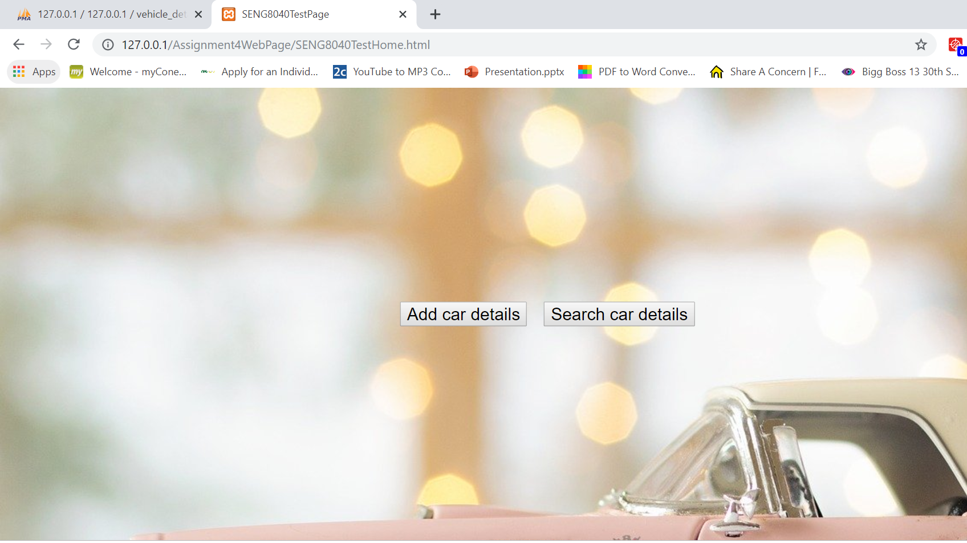

Add Page

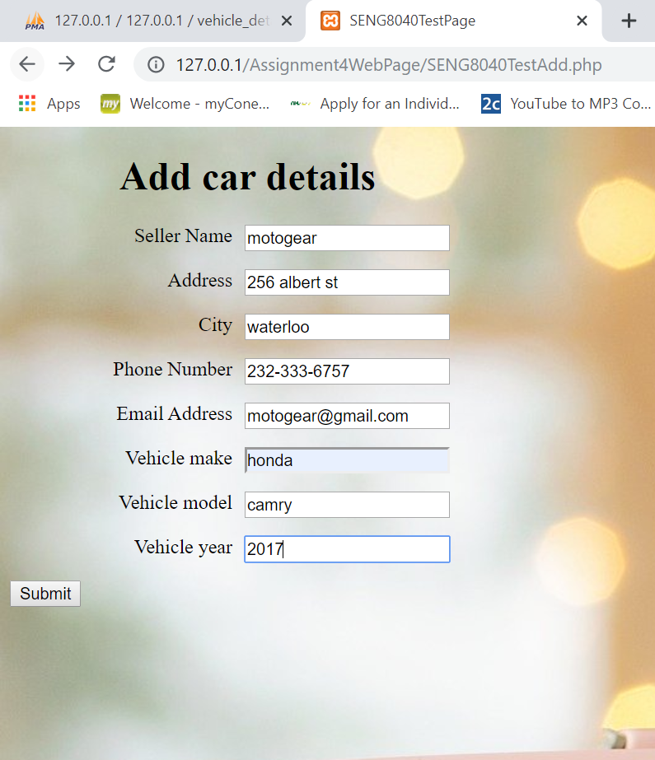

Inserted Data Page

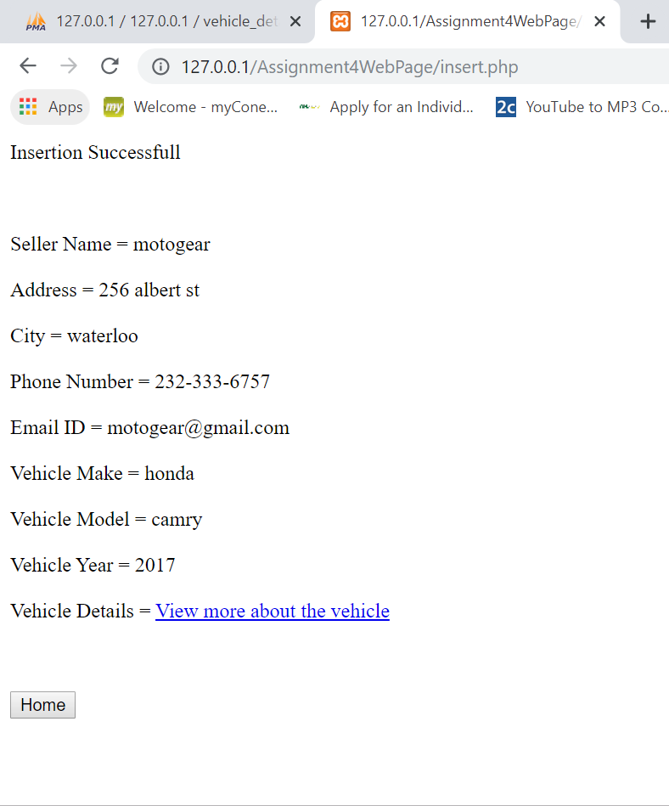

Display all data from database page

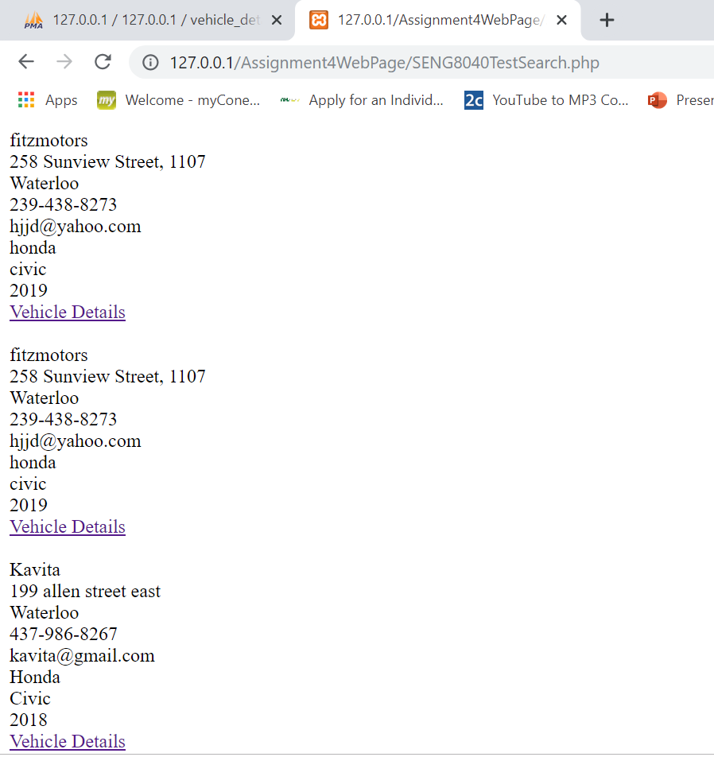

**C# Source Code of System Test**

import static com.kms.katalon.core.checkpoint.CheckpointFactory.findCheckpoint

import static com.kms.katalon.core.testcase.TestCaseFactory.findTestCase

import static com.kms.katalon.core.testdata.TestDataFactory.findTestData

import static com.kms.katalon.core.testobject.ObjectRepository.findTestObject

import com.kms.katalon.core.checkpoint.Checkpoint as Checkpoint

import com.kms.katalon.core.checkpoint.CheckpointFactory as CheckpointFactory

import com.kms.katalon.core.mobile.keyword.MobileBuiltInKeywords as MobileBuiltInKeywords

import com.kms.katalon.core.model.FailureHandling as FailureHandling

import com.kms.katalon.core.testcase.TestCase as TestCase

import com.kms.katalon.core.testcase.TestCaseFactory as TestCaseFactory

import com.kms.katalon.core.testdata.TestData as TestData

import com.kms.katalon.core.testdata.TestDataFactory as TestDataFactory

import com.kms.katalon.core.testobject.ObjectRepository as ObjectRepository

import com.kms.katalon.core.testobject.TestObject as TestObject

import com.kms.katalon.core.webservice.keyword.WSBuiltInKeywords as WSBuiltInKeywords

import com.kms.katalon.core.webui.driver.DriverFactory as DriverFactory

import com.kms.katalon.core.webui.keyword.WebUiBuiltInKeywords as WebUiBuiltInKeywords

import internal.GlobalVariable as GlobalVariable

import com.kms.katalon.core.webui.keyword.WebUiBuiltInKeywords as WebUI

import com.kms.katalon.core.mobile.keyword.MobileBuiltInKeywords as Mobile

import com.kms.katalon.core.webservice.keyword.WSBuiltInKeywords as WS

import com.thoughtworks.selenium.Selenium

import org.openqa.selenium.firefox.FirefoxDriver

import org.openqa.selenium.WebDriver

import com.thoughtworks.selenium.webdriven.WebDriverBackedSelenium

import static org.junit.Assert.*

import java.util.regex.Pattern

import static org.apache.commons.lang3.StringUtils.join

WebUI.openBrowser('https://www.katalon.com/')

def driver = DriverFactory.getWebDriver()

String baseUrl = "https://www.katalon.com/"

selenium = new WebDriverBackedSelenium(driver, baseUrl)

selenium.open("http://127.0.0.1/Assignment4WebPage/SENG8040TestHome.html")

selenium.click("xpath=(.//*[normalize-space(text()) and normalize-space(.)='Search car details'])[1]/preceding::button[1]")

selenium.click("name=sname")

selenium.type("name=sname", "jaspreet")

selenium.click("name=address")

selenium.type("name=address", "288 allen st")

selenium.click("name=city")

selenium.type("name=city", "kitchener")

selenium.click("name=phNum")

selenium.type("name=phNum", "222-222-4343")

selenium.click("name=email")

selenium.type("name=email", "jassibhullar@yahoo.com")

selenium.click("name=make")

selenium.type("name=make", "maruti")

selenium.click("name=model")

selenium.type("name=model", "swift")

selenium.click("name=year")

selenium.type("name=year", "2019")

selenium.click("name=submit")

selenium.click("link=View more about the vehicle")

selenium.click("name=backHome")

selenium.click("xpath=(.//*[normalize-space(text()) and normalize-space(.)='Add car details'])[1]/following::button[1]")

selenium.click("xpath=(.//*[normalize-space(text()) and normalize-space(.)='Civic'])[1]/following::a[1]")

**WebPage Source Code**

<!DOCTYPE html>

<html lang="en-US">

<head>

<link rel="stylesheet" href="myStyle.css">

<title>SENG8040TestPage</title>

</head>

<body>

<div class="wrapper">

<button class="buttonHome" style="font-size:20px" onclick="window.location='SENG8040TestAdd.php'">Add car details</button>&nbsp;&nbsp;&nbsp;&nbsp;

<button class="buttonHome" style="font-size:20px" onclick="window.location='SENG8040TestSearch.php'">Search car details</button>

</div>

</body>

</html>

SENG8040TestAdd.php

<!DOCTYPE html>

<html lang="en-US">

<head>

<link rel="stylesheet" href="myStyle.css">

<title>SENG8040TestPage</title>

</head>

<form method="POST" action="insert.php">

<body>

<h1 class="headingadd">Add car details</h1>

<label>Seller Name</label>

<input type="text" name="sname" placeholder="Enter Seller Name" required><br><br>

<label>Address</label>

<input type="text" name="address" placeholder="Enter Address" required><br><br>

<label>City</label>

<input type="text" name="city" placeholder="Enter City" required><br><br>

<label>Phone Number</label>

<input type="text" name="phNum" pattern=[0-9]{3}-[0-9]{3}-[0-9]{4} placeholder="xxx-xxx-xxxx" required><br><br>

<label>Email Address</label>

<input type="text" name="email" pattern="[a-z0-9._%+-]+@[a-z0-9.-]+\.[a-z]{2,}$" placeholder="xyz.ca@xyz.com" required><br><br>

<label>Vehicle make</label>

<input type="text" name="make" placeholder="Enter Vehicle Make" required><br><br>

<label>Vehicle model</label>

<input type="text" name="model" placeholder="Enter Vehicle Model" required><br><br>

<label>Vehicle year</label>

<input type="text" name="year" pattern=[0-9]{4} placeholder="Enter Vehicle Year" required><br><br>

<button class="buttonAdd" name="submit">Submit</button>

<br><br>

</form>

</body>

</html>

SENG8040TestSearch.php

<?php

$servername = "localhost";

$username = "root";

$password = "";

$database = 'vehicle_details';

// Create a connection

$conn = mysqli_connect($servername, $username, $password, $database);

$sql = "SELECT * FROM vehicle_details";

$outcme= $conn->query($sql);

if($outcme->num_rows > 0){

while ($row = $outcme->fetch_assoc())

{

$linkRead=$row['vehicleLink'];

echo

"

<label>{$row['sellerName']}</label><br>

<label>{$row['address']}</label><br>

<label>{$row['city']}</label><br>

<label>{$row['phoneNumber']}</label><br>

<label>{$row['emailAddress']}</label><br>

<label>{$row['vehicleMake']}</label><br>

<label>{$row['vehicleModel']}</label><br>

<label>{$row['vehicleYear']}</label><br>

<label><a href='$linkRead'>Vehicle Details</a></label>

<br><br>

";

}

}

?>

<?php

$sname=$_POST['sname'];

$address=$_POST['address'];

$city=$_POST['city'];

$phNum=$_POST['phNum'];

$email=$_POST['email'];

$make=$_POST['make'];

$model=$_POST['model'];

$year=$_POST['year'];

$servername = "localhost";

$username = "root";

$password = "";

$database = 'vehicle_details';

$conn = mysqli_connect($servername, $username, $password, $database);

$linkGenerateMake=str_replace(" ","-",$make);

$linkGenerateModel=str_replace(" ","-",$model);

$linkGenerated="http://www.jdpower.com/cars/".$linkGenerateMake."/".$linkGenerateModel."/".$year;

$sql="INSERT INTO vehicle_details(sellerName,address,city,phoneNumber,emailAddress,vehicleMake,vehicleModel,vehicleYear,vehicleLink) VALUES('".$sname."','".$address."','".$city."','".$phNum."','".$email."','".$make."','".$model."','".$year."','".$linkGenerated."')";

$result = $conn->query($sql);

if($result = false){

echo "Insertion failed";

die();

}

else{

echo "Insertion Successfull";

}

?>

<br><br><br><br>

<label>Seller Name =</label>

<label name="disSellername"><?php echo "$sname"; ?></label>

<br><br>

<label>Address =</label>

<label name="disAddress"><?php echo "$address"; ?></label>

<br><br>

<label>City =</label>

<label name="disCity"><?php echo "$city"; ?></label>

<br><br>

<label>Phone Number =</label>

<label name="disPhoneNumber"><?php echo "$phNum"; ?></label>

<br><br>

<label>Email ID =</label>

<label name="disEmail"><?php echo "$email"; ?></label>

<br><br>

<label>Vehicle Make =</label>

<label name="disVehMake"><?php echo "$make"; ?></label>

<br><br>

<label>Vehicle Model =</label>

<label name="disVehModel"><?php echo "$model"; ?></label>

<br><br>

<label>Vehicle Year =</label>

<label name="disVehYr"><?php echo "$year"; ?></label>

<br><br>

<label>Vehicle Details =</label>

<label name="disVehDetail"><a href="<?php echo "$linkGenerated"; ?>">View more about the vehicle</a></label>

<br><br><br><br>

<button name="backHome" onclick="window.location='SENG8040TestHome.html'">Home</button>

<br><br><br><br>

<label>Seller Name =</label>

<label name="disSellername"><?php echo "$sname"; ?></label>

<br><br>

<label>Address =</label>

<label name="disAddress"><?php echo "$address"; ?></label>

<br><br>

<label>City =</label>

<label name="disCity"><?php echo "$city"; ?></label>

<br><br>

<label>Phone Number =</label>

<label name="disPhoneNumber"><?php echo "$phNum"; ?></label>

<br><br>

<label>Email ID =</label>

<label name="disEmail"><?php echo "$email"; ?></label>

<br><br>

<label>Vehicle Make =</label>

<label name="disVehMake"><?php echo "$make"; ?></label>

<br><br>

<label>Vehicle Model =</label>

<label name="disVehModel"><?php echo "$model"; ?></label>

<br><br>

<label>Vehicle Year =</label>

<label name="disVehYr"><?php echo "$year"; ?></label>

<br><br>

<label>Vehicle Details =</label>

<label name="disVehDetail"><a href="<?php echo "$linkGenerated"; ?>">View more about the vehicle</a></label>

<br><br><br><br>

<button name="backHome" onclick="window.location='http://localhost/SENG8040TestHome.html'">Home</button>

myStyle.css

body {

background-image: url("car.jpg");

}

.wrapper {

position:absolute;

left: 50%;

top: 50%;

-webkit-transform: translate(-50%, -50%);

transform: translate(-50%, -50%);

}

h1{

position:relative;

left:4%

}

.headingadd{

position:relative;

left:7%

}

label{

width:180px;

clear:left;

text-align:right;

padding-right:10px;

}

input, label{

float:left;

}

.buttonAdd{

transition: .5s ease;

top: 70%;

left: 14.4%;

}

**NUnit GUI Console Screenshot**

**Screenshot of Commits In GIT**